6-2 Activity: Advanced Data Visualization with Python
Explain how specific design choices contributed to the clarity and impact of the visualizations: The use of informative tiles, axis labels with units as applicable, and legends were incorporated into the visualizations to aid the user in understanding the period of the analysis, the type of data being used in the figures (i.e. daily, weekly, or monthly), and the countries being presented in the analysis. The titles incorporated consistent formatting in the presentation of numbers (using ten or 10 consistently across all figures), made it evident whether the figures were for specific countries or represented global data, and what period of time the underlying data was for. Additionally, color-blind friendly color palettes were used to ensure that a broad audience could easily distinguish between the countries being presented. Finally, zero baselines were incorporated to prevent the information from being skewed (zyBooks, 2026).
Describe any challenges you faced when implementing interactivity and animation and how you addressed each challenge: With regards to implementing the interactive graphs, the challenge was encountered regarding overwhelming the audience with options. This was overcome by focusing on what the overall purpose was for each interactive chart to guide the level and type of interactivity. For the Interactive Time Series graph this meant adding clarification on how the data could be manipulated and pop-up boxes that appeared when hovering over the graph showing the date and the number of deaths in thousands, please see Figure 1. For the Overview+Detail graph this challenge was overcome by adding clarifying instructions about how the overview and detail portions interact and how to reset the graphs and providing detailed information when hovering over points on the detail section of the figure, please see Figure 2. With regards to implementing animation, it was necessary to weigh the need for simplicity while also providing pertinent information to the audience. Since the data spanned a large period of several years and contained over two hundred countries it was difficult to decide how to best create an animation that provided useful information. To address this challenge, the created animation was for the entire dataset period of 1/5/2020 to 8/4/2024 but only the top three countries in terms of cumulative total deaths for the period were presented, the United States, Brazil, and India. While these countries had the highest cumulative deaths the animation demonstrated that all three had very different weekly death rates over time. Additionally, using a slower animation rate ensured that the audience had sufficient time to identify and examine the lines for each of the countries as the animation progressed through time. The animation also provided the ability to speed up or slow down the animation as well as pause the animation. These factors combined allowed for the animation to enhance the information presented in the Overview+Detail visual by allowing the user to gradually see the changes in the COVID-19 deaths over time for the countries and made it easier to identify peaks for each country and whether the countries had similar or different fluctuations of COVID-19 deaths during the analysis period.
Evaluate how accessibility and cognitive load considerations were incorporated into the design of the visualizations: The purpose of the correlation matrix heatmap was to demonstrate whether the patterns of COVID-19 deaths between two countries had any correlation. It took the form of a ten-by-ten matrix since it included the top ten countries with the highest reported cumulative deaths for the period of 1/5/2020 to 8/4/2024. Since no negative values were reported in the matrix using a traditional gradient showing values from 1 to -1 can cause reduced contrast in the colors used since only half of the palette is being used, please see Figure 3 for an example. Additionally, the orientation of the titles should be taken into consideration so that names of the countries on both axes are easily readable, please see Figure 3. The improved figure changes the orientation of the axis titles and labels so that they are easier to read and the color scale has been changed to go from 0 to 1 so that correlations below and above 0.50 can be easily distinguished, please see Figure 4. The purpose of the hierarchical bar chart is to show the total cumulative deaths reported by the top twenty countries during the analysis period. Important factors in this visual are the proper scaling of the y-axis, column data labels, and incorporation of color-blind friendly colors in the subcategory colorization. As demonstrated in Figure 5, when these factors are not considered it can be difficult at a glance to determine the number of cases reported by each country. Alternatively, Figure 6 takes into account that the scale should always begin at zero for bar charts (zyBooks, 2026), has clearer identification of the y-axis values by utilizing units of one million in increments of 0.2M, or 200,000, incorporates a color-blind friendly palette, and provides a total column value for each bar chart showing the total deaths per the top twenty countries for the analysis period. The purpose of the times series chart is to show the global daily deaths from COVID-19 for the analysis period. Since the analysis period covers several years providing the data on a daily level impacts the effectiveness of the graph by making it very difficult to read and interpret the graph, please see Figure 7. Also, this graph does not provide any annotations that provide explanations for sudden increases or decreases in the number of COVID-19 deaths. Figure 8, on the other hand, presents the data on a monthly basis with the x-axis on an increment of three months and includes annotations for key events during the pandemic (Siddiqui, Alhamdi, & Alghamdi, 2022) (CDC Museum COVID-19 Timeline, n.d.) (DeGrasse & Black, 2023). These factors combined allowed for accessibility and cognitive load factors to be properly addressed in the design of the graphs.

References
CDC Museum COVID-19 Timeline. (n.d.). Retrieved from CDC: https://www.cdc.gov/museum/timeline/covid19.html
DeGrasse, D., & Black, S. (2023, June 8). The Rise of SARS-CoV-2 (COVID-19) Omicron Subvariant Pathogenicity. Cureus. Retrieved from The Rise of SARS-CoV-2 (COVID-19) Omicron Subvariant Pathogenicity: https://pmc.ncbi.nlm.nih.gov/articles/PMC10260278/
Siddiqui, S., Alhamdi, H., & Alghamdi, H. (2022, May 4). Recent Chronology of COVID-19 Pandemic. Front Public Health. Retrieved from Recent Chronology of COVID-19 Pandemic: https://pmc.ncbi.nlm.nih.gov/articles/PMC9114873/
zyBooks, a. W. (2026). Data Literacy and Visualization.

Figures
Figure 1: Interactive Time Series with Zoom- Design Choices
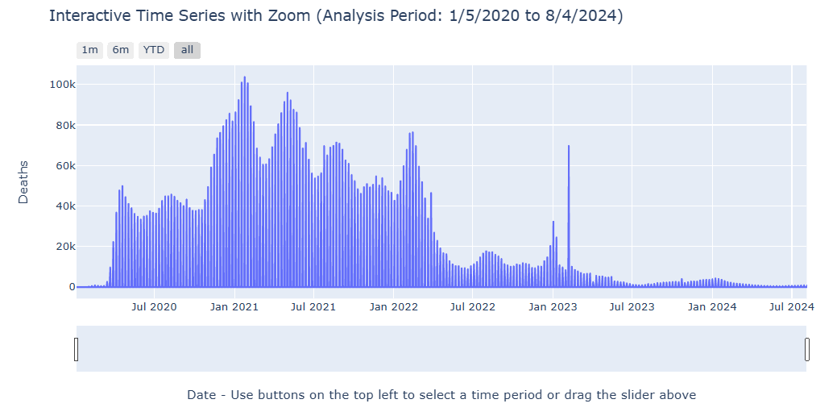

Figure 1: Interactive Time Series with Zoom- Design Choices (continued)
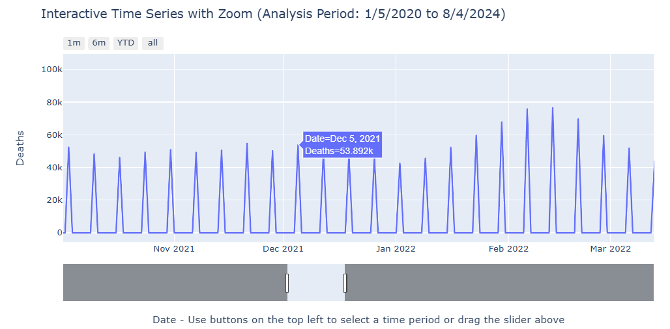

Figure 2: Overview+Detail Chart- Design Choices
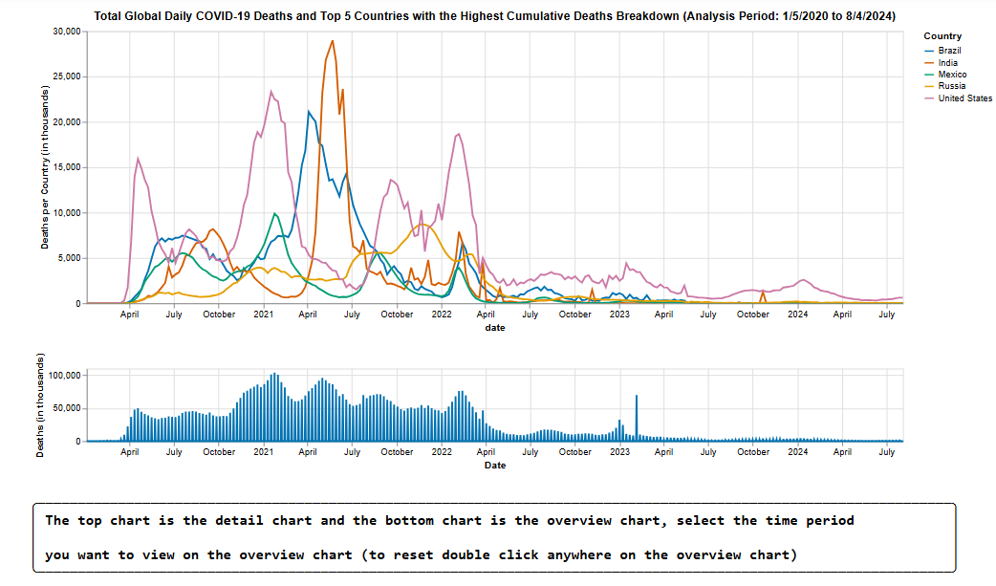

Figure 2: Overview+Detail Chart- Design Choices (continued)
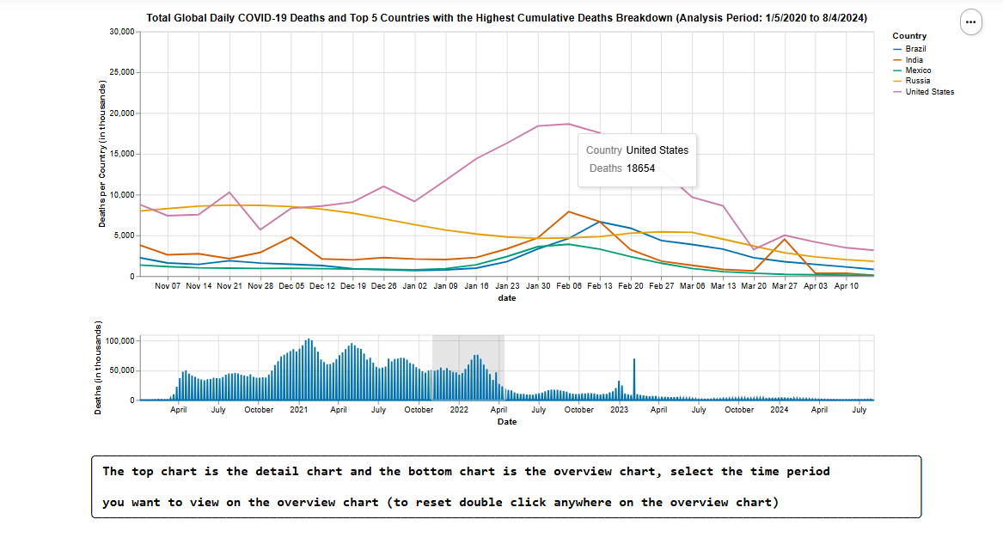

Figure 3: Heatmap: Poor Design- Color Usage & Readability
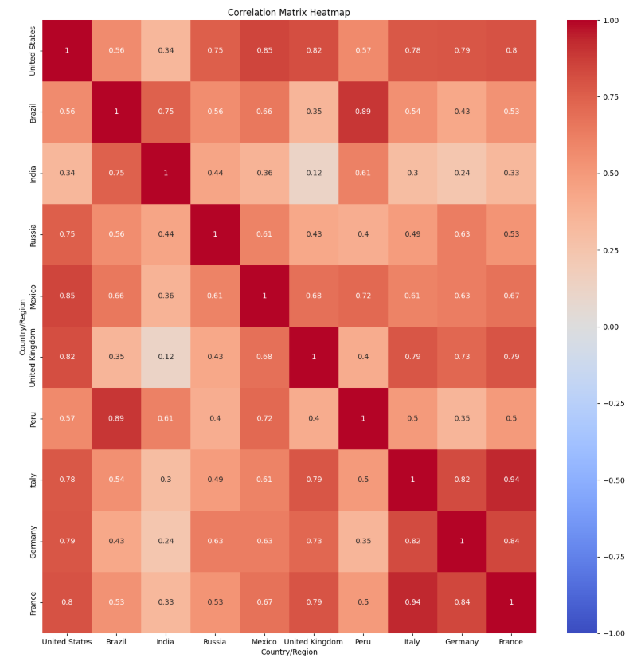
Figure 4: Heatmap: Improved Design
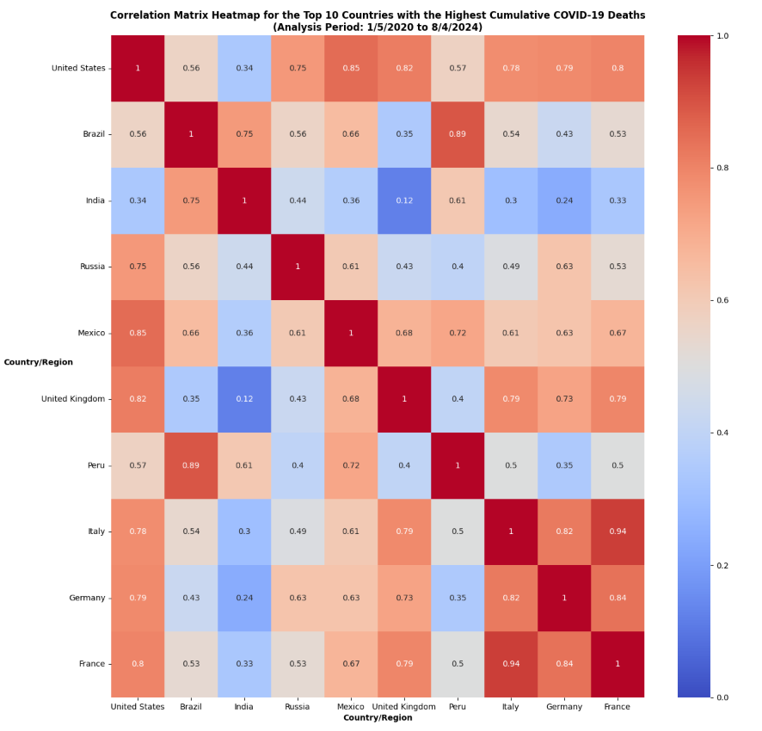
Figure 5: Bar Chart Graph- Poor Design
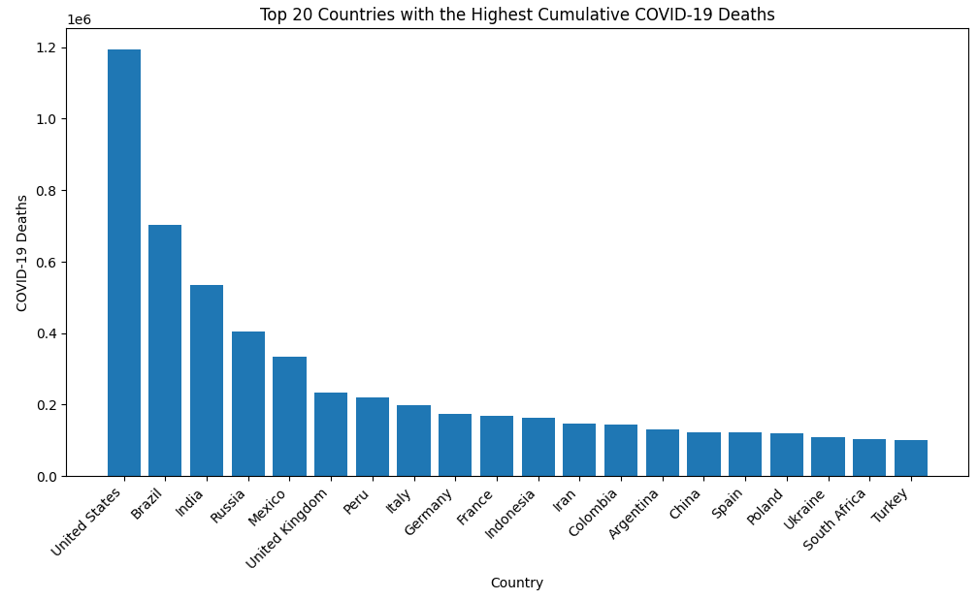

Figure 6: Bar Chart Graph- Improved Design
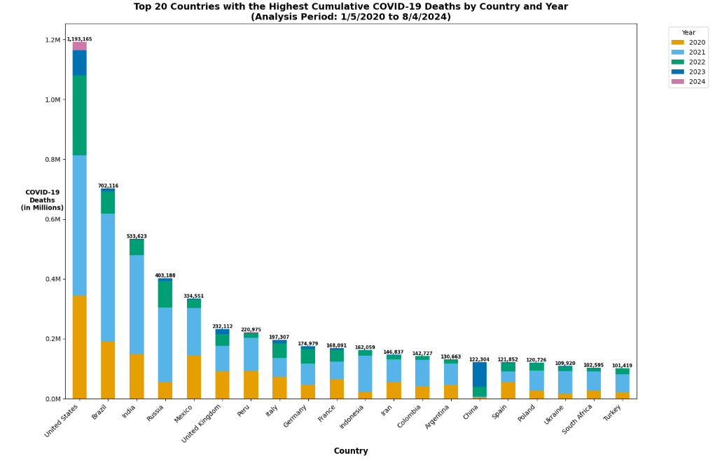

Figure 7: Time Series Graph- Poor Design
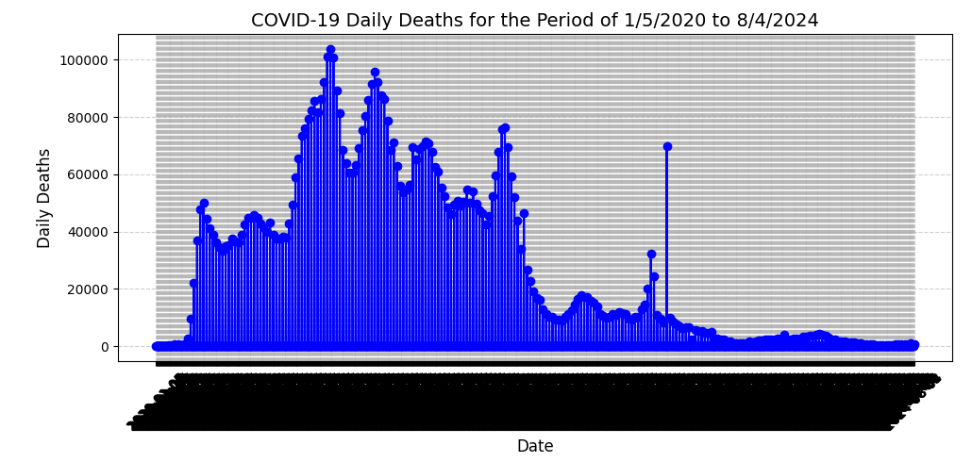

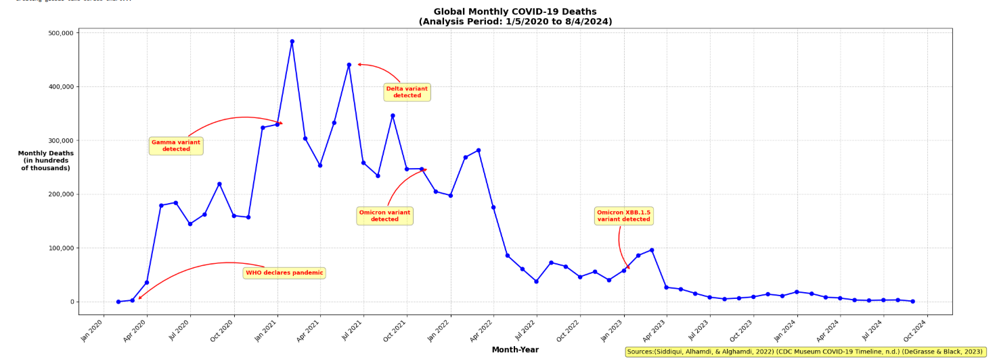
Figure 8: Time Series Graph- Improved Design

